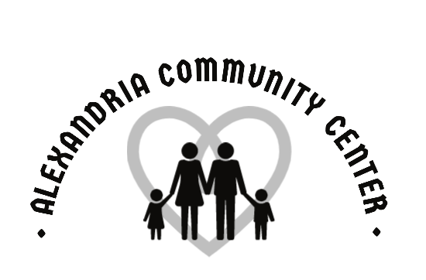
Creative Art
at
The ACC!

The Alexandria Community Center is hosting a creative art class for kids! There will be two separate class dates and each class we will be completing a different craft. There is a limited amount of space, so get your registration and money in as quickly as possible! Below is the important information…

Who: Registration is open to students that are completing 1st – 6th grades.

Fee: $10 per student per session.

When: Session 1 – Wednesday, July 6th
10:30 am – 11:30 am
**Art with Mason Jars

Session 2 – Wednesday, July 20th
10:30 am – 11:30 am
**Canvas painting

Where: @ the ACC (315 S. Harrison St.)

**The projects in Session 1 will differ from Session 2. So, if your child would like to sign up for both sessions, they will not be doing repeat projects!

*** Return this registration form with $10 to the ACC during business hours. There is also an online registration available on the ACC website. Please contact Rachel Young at 765-724-7728 or rachelyoungacc@gmail.com with any questions or concerns***

__________________________________________________________________________________________

Student’s name____________________________________ Phone Number____________________________

Parent Email ___________________________________

Age_____ Grade________

Does your child have any health problems that we should be aware of? ________________________________

Fees must accompany this form unless other arrangements have been made. No refunds will be made. ACC is not responsible for accidents or injuries.

In consideration of participation in the above program(s) conducted by the Alexandria Community Center & Alexandria Community Schools, I do hereby agree to hold free from any liability the ACC and its respective officers, employees, and volunteers. I do hereby for myself, my heirs, executors, and administrators waive, release, and forever discharge and all rights and claims for damages, which may hereafter, accrue to me arising out of or connected with my child’s participation in this program. I attest and verify that the participant listed above is physically fit and I have read this form and understand the expectations of this program.
I give the Alexandria Community Center permission to use pictures taken of my child during sports activities.

Parent/Guardian (please print) _______________________________ Signature_________________________

I would like to contribute $_______ to a scholarship fund that will allow all interested area children to participate in ACC programs.

